Skin Burn Detection using Machine Learning

Project Overview

Objective

The objective of this project is to develop a proof of skin burn detection system utilizing the YOLOv5s model. The system will classify burns into three severity classes: Class 1 (Minor), Class 2 (Moderate), and Class 3 (Severe).

Technology Stack
Tools: Roboflow, Kaggle Notebook, Tensorboard
Libraries: YOLOv5, Python, matplotlib, OpenCV, Pillow, scipy

Dataset
The dataset utilized for this project comprises a total of 5,855 meticulously curated images. These images have undergone extensive preprocessing and augmentation to ensure their suitability for training machine learning models, with a specific focus on computer vision tasks, notably object detection and image classification. The comprehensive preparation of the dataset lays a robust foundation for model training and evaluation.

Data Collection
The data collection process for this project was multifaceted, designed to assemble a diverse and comprehensive set of images. Initially, web scraping techniques were employed to gather images from a variety of sources, including Google and pre-existing datasets. This approach ensured the inclusion of a wide range of images, capturing diverse aspects of the subject matter under consideration.

In addition to web scraping, a pivotal element of data collection was the manual selection and annotation of images. This critical step involved a meticulous curation process, where only the most relevant and high-quality images were retained. Manual annotation, facilitated by tools like Roboflow, played a crucial role in labeling and categorizing the images, enabling supervised machine learning tasks.

Data Preprocessing
The dataset underwent a series of preprocessing steps aimed at enhancing its quality and suitability for machine learning tasks.

Auto-Orient: Correcting Image Orientation
One of the initial preprocessing steps focused on image orientation correction. This step ensured consistent orientation across all images, eliminating potential distortions caused by variations in orientation. This correction process significantly contributed to the uniformity of the dataset.

Resize: Uniform Image Dimensions
To streamline processing and analysis, all images were resized to a standardized dimension of 640 x 640 pixels. This standardization simplified compatibility with the selected model architecture and eased subsequent data processing steps.

Augmentations: Increasing Data Variability
To augment the dataset and improve model generalization, various transformations were applied to the images. This included random rotation within a range of -20° to +20°, as well as rotations in clockwise, counter-clockwise, and upside-down orientations. These augmentations introduced variability into the dataset, enabling the model to better adapt to real-world scenarios.

As a result of these comprehensive efforts, the dataset now comprises a total of 14,044 labeled images.

Exploratory Data Analysis

Sampled Images
In this section, we delve into our dataset by examining a carefully chosen selection of images. These images provide us with a visual insight into the nature of the data, allowing us to assess its diversity and quality. By examining these sampled images, we can better understand the characteristics of the dataset we are working with, which is crucial for the success of our skin burn detection model.
[images graph]

Class Distribution
Understanding the distribution of classes within our dataset is fundamental to our skin burn detection project. Here, we present a breakdown of the dataset's class distribution:
- Class 1: Minor Burns - 2,407 images
- Class 2: Moderate Burns - 2,606 images
- Class 3: Severe Burns - 922 images
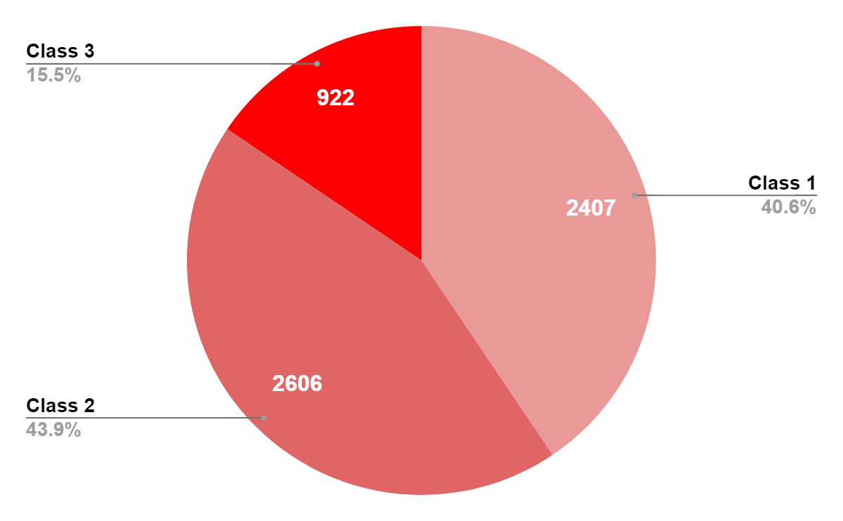
This distribution information is essential for ensuring that our machine learning model is trained on a balanced representation of each burn class, ultimately contributing to its accuracy and effectiveness.

Data Split Analysis
To ensure the integrity of our machine learning model, we carefully split our dataset into training, validation, and test sets. This section includes a graphical representation illustrating the distribution of images across these splits. Understanding how data is allocated for training and evaluation is a crucial aspect of the model development process.
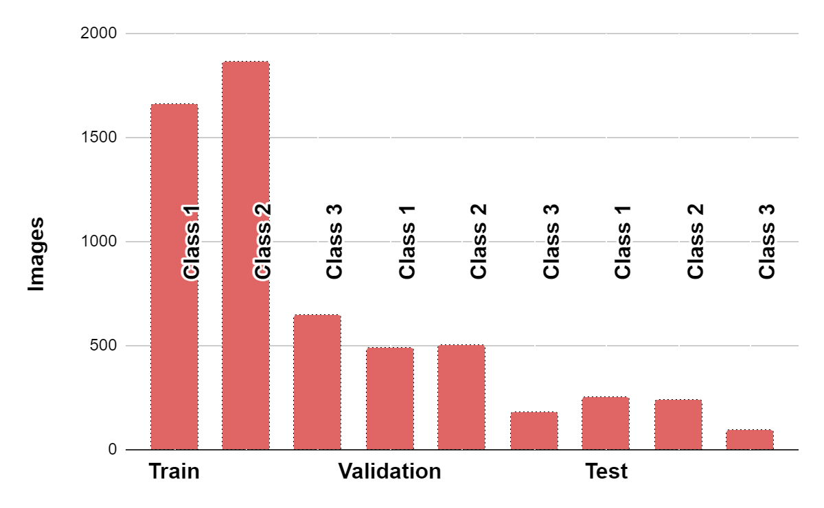

Model Architecture
The YOLOv5 model architecture consisted of 214 layers with a total of 7,027,720 parameters. This architecture incorporated convolutional layers, skip connections, and anchor boxes. Additionally, a feature pyramid network (FPN) was utilized to address objects at various scales, enhancing the model's ability to detect skin burn in images.
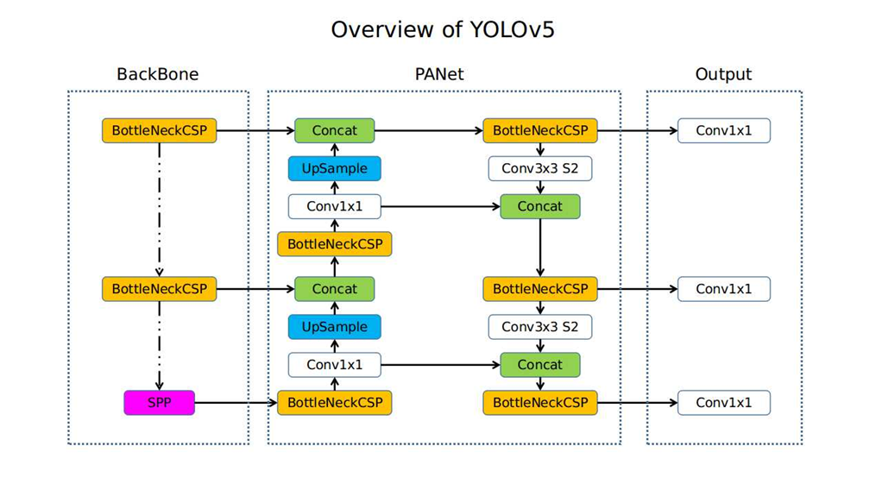

Backbone
The backbone serves as the core of the YOLOv5 network. In this version, YOLOv5 adopts the New CSP-Darknet53 structure, a refined iteration of the Darknet architecture previously employed. This component is responsible for extracting critical features from the input data, enabling the network to identify patterns and structures within the images.

Neck
The neck of the YOLOv5 model acts as the intermediary, connecting the backbone to the head. YOLOv5 incorporates the SPPF (Spatial Pyramid Pooling with FPN) and New CSP-PAN (Contextual Spatial Pyramid with Path Aggregation Network) structures in this segment. These additions enhance the model's ability to capture multi-scale information and contextual relationships among features extracted by the backbone.

Head
The head is the final segment of the YOLOv5 architecture, and it plays a pivotal role in generating the ultimate output. YOLOv5 leverages the YOLOv3 Head, a specialized component designed for precise object detection. This head is responsible for producing predictions regarding the presence and location of skin burns in the input images.

In summary, the YOLOv5 architecture's backbone, neck, and head collectively work in harmony to empower the model with the capabilities needed for accurate skin burn detection. This architecture excels at feature extraction, multi-scale information integration, and precise output generation, making it a robust choice for this critical medical imaging task.

Model Training
In the pursuit of developing an efficient skin burn detection system using machine learning, our journey began with the critical phase of model training. This phase encompassed an array of settings that we customized to attain an optimal performance.

Training Details

Hyperparameters
In the training phase, hyperparameters were meticulously tuned to optimize the model's performance. These included the learning rate (lr0) set at 0.01, learning rate factor (lrf) of 0.01, momentum of 0.937, and weight decay of 0.0005. Other key hyperparameters included warmup epochs (3.0), warmup momentum (0.8), warmup bias learning rate (0.1), box loss weight (0.05), class loss weight (0.5), class power weight (1.0), object loss weight (1.0), and object power weight (1.0). Additionally, parameters such as IoU threshold (iou_t), anchor T, and focal loss gamma (fl_gamma) were fine-tuned. Augmentation settings, including HSV augmentation, degrees, translate, scale, shear, perspective, flipud, fliplr, mosaic, mixup, and copy_paste, played a pivotal role in the training process.

Loss Function
The loss function used during training was a combination of several components, each serving a specific purpose. These components included objectness loss, classification loss, localization loss, and confidence loss. These loss terms worked collaboratively to enable the model to detect and classify skin burn accurately in images. The weights assigned to these loss components, such as class loss weight and object loss weight, were adjusted to balance their contributions.

Optimization Technique
Stochastic Gradient Descent (SGD) with a learning rate of 0.01 was employed as the optimization technique. SGD was responsible for iteratively updating the model's weights to minimize the defined loss function, thus facilitating the model's convergence during training.

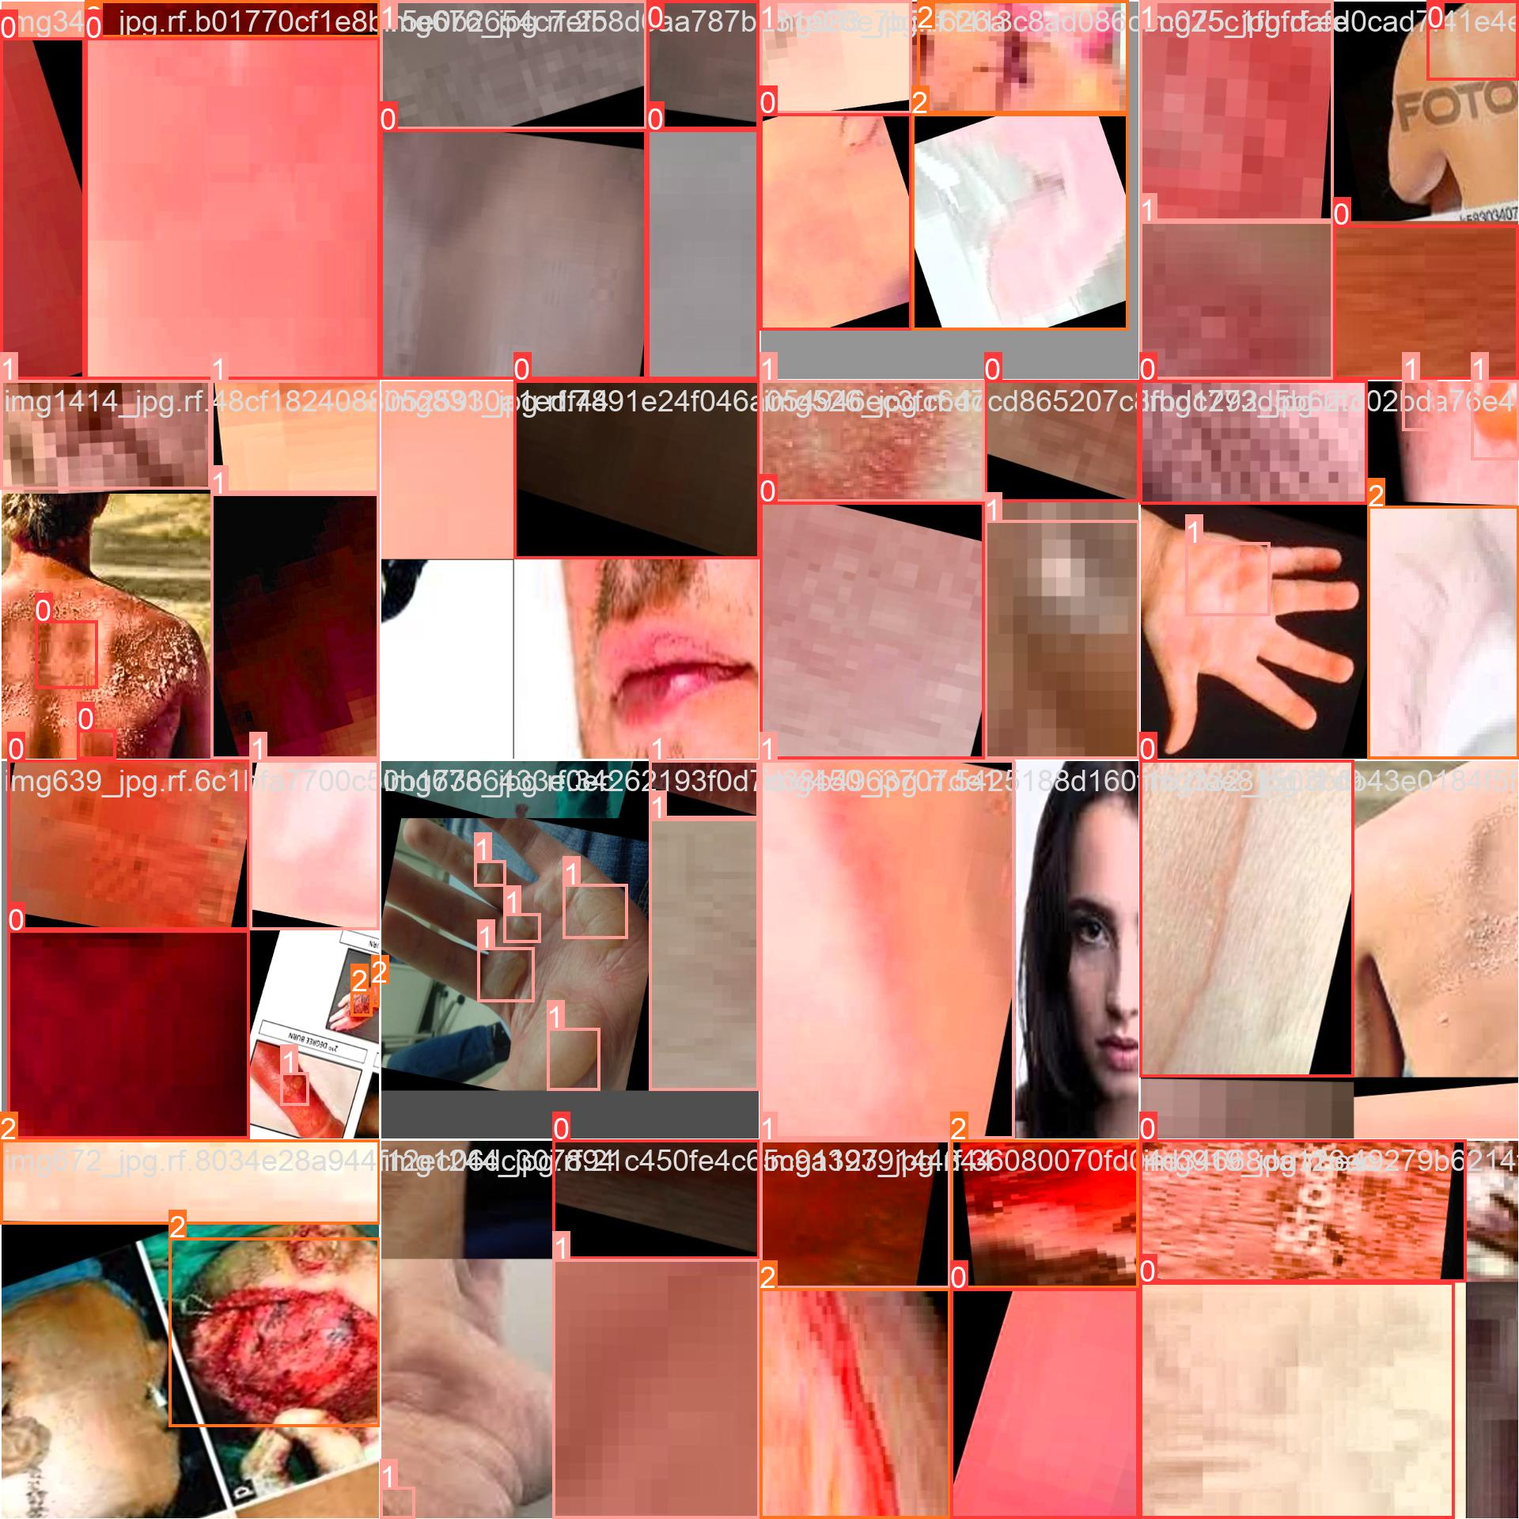

Evaluation Metrics

Precision
Precision is a crucial evaluation metric that measures the proportion of true positive predictions out of all positive predictions made by our model. It helps us understand the accuracy of our model in correctly identifying skin burn cases. High precision indicates a low rate of false positives, signifying the model's ability to minimize misclassifications.
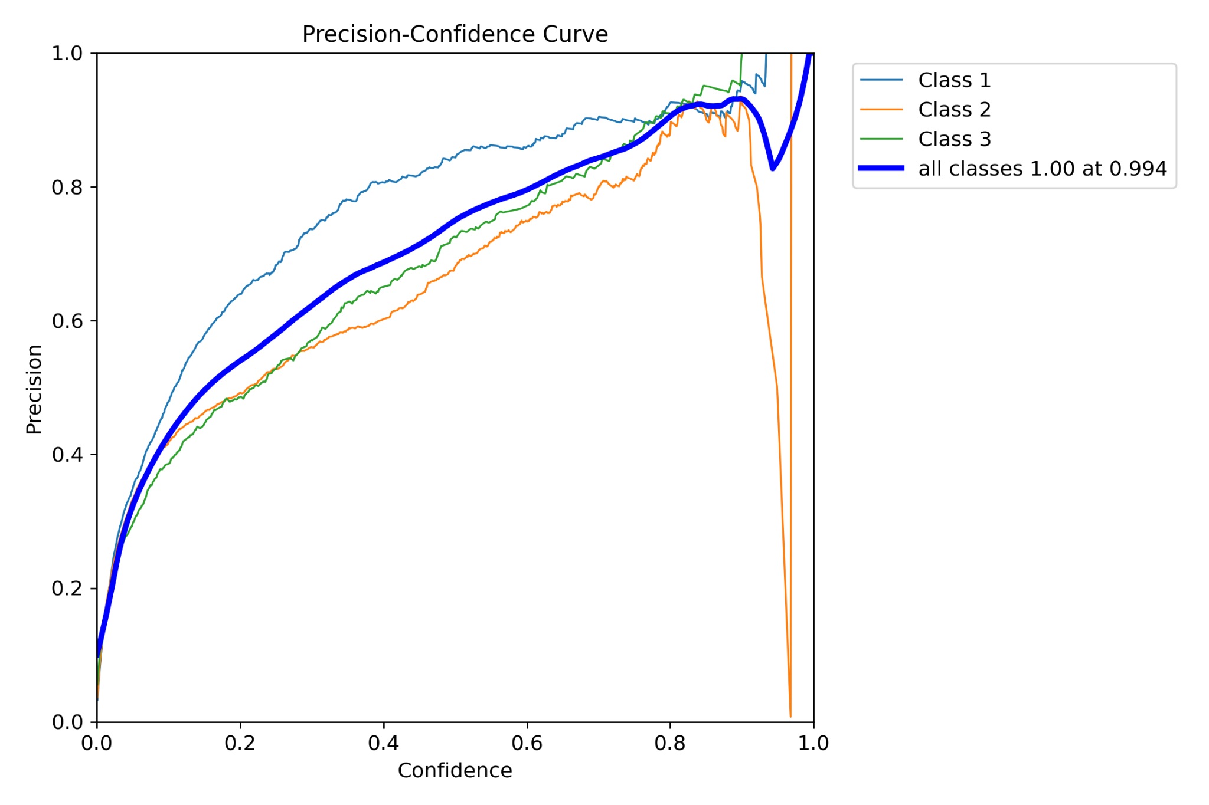

Recall
Recall, also known as sensitivity or true positive rate, quantifies the proportion of actual skin burn cases that our model correctly identified. It is a valuable metric for evaluating the model's ability to detect all instances of skin burn. A high recall indicates that the model is effective at identifying a large portion of true positive cases.
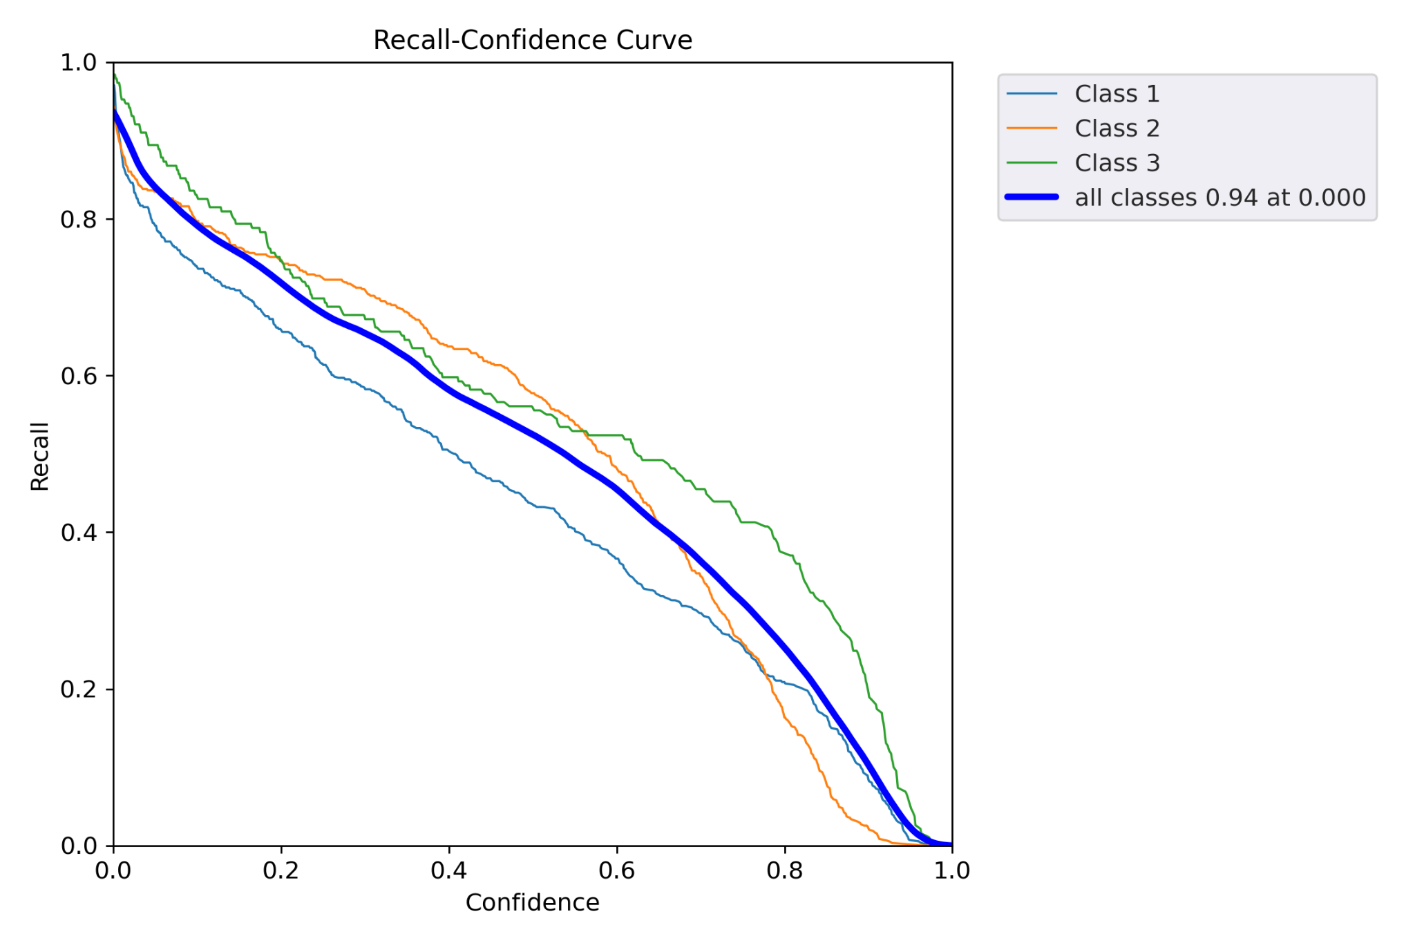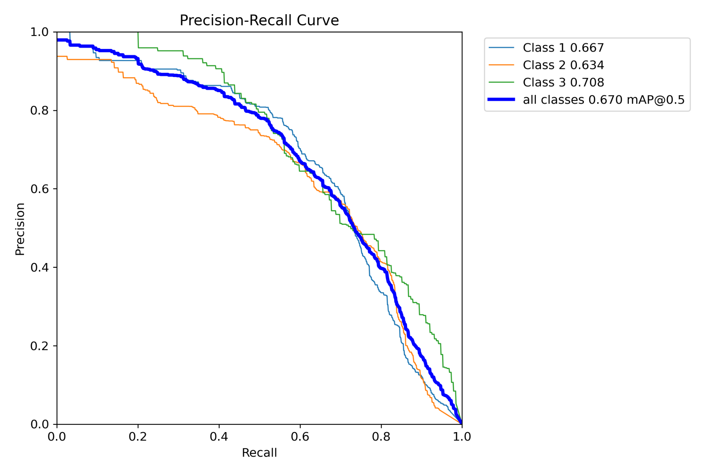

F1-Score
The F1-score is a metric that strikes a balance between precision and recall. It provides a single value that combines both metrics into a comprehensive measure of model performance. This is particularly useful when dealing with imbalanced datasets or when there is a need to find a trade-off between precision and recall.
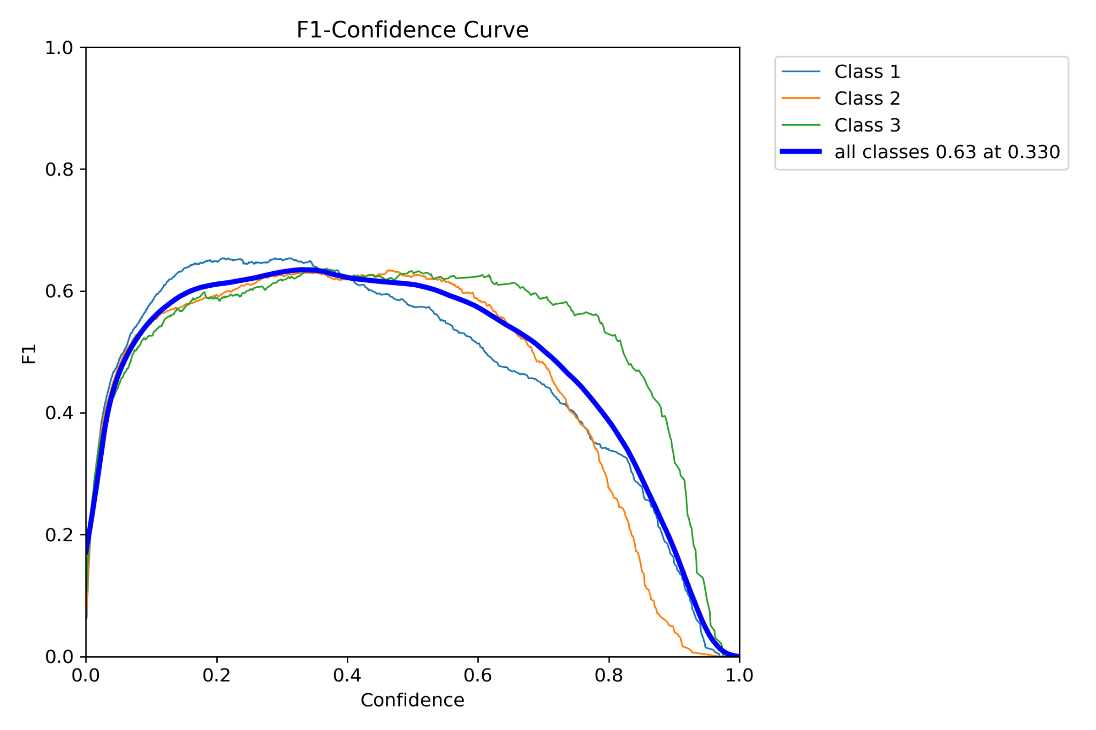

In summary, these evaluation metrics played a pivotal role in our project by providing a well-rounded assessment of our skin burn detection models. Each metric addresses specific aspects of model performance, ensuring that our system is both accurate and reliable in identifying skin burn cases while minimizing false positives and maximizing true positives.

Model Performance

Confusion Matrix
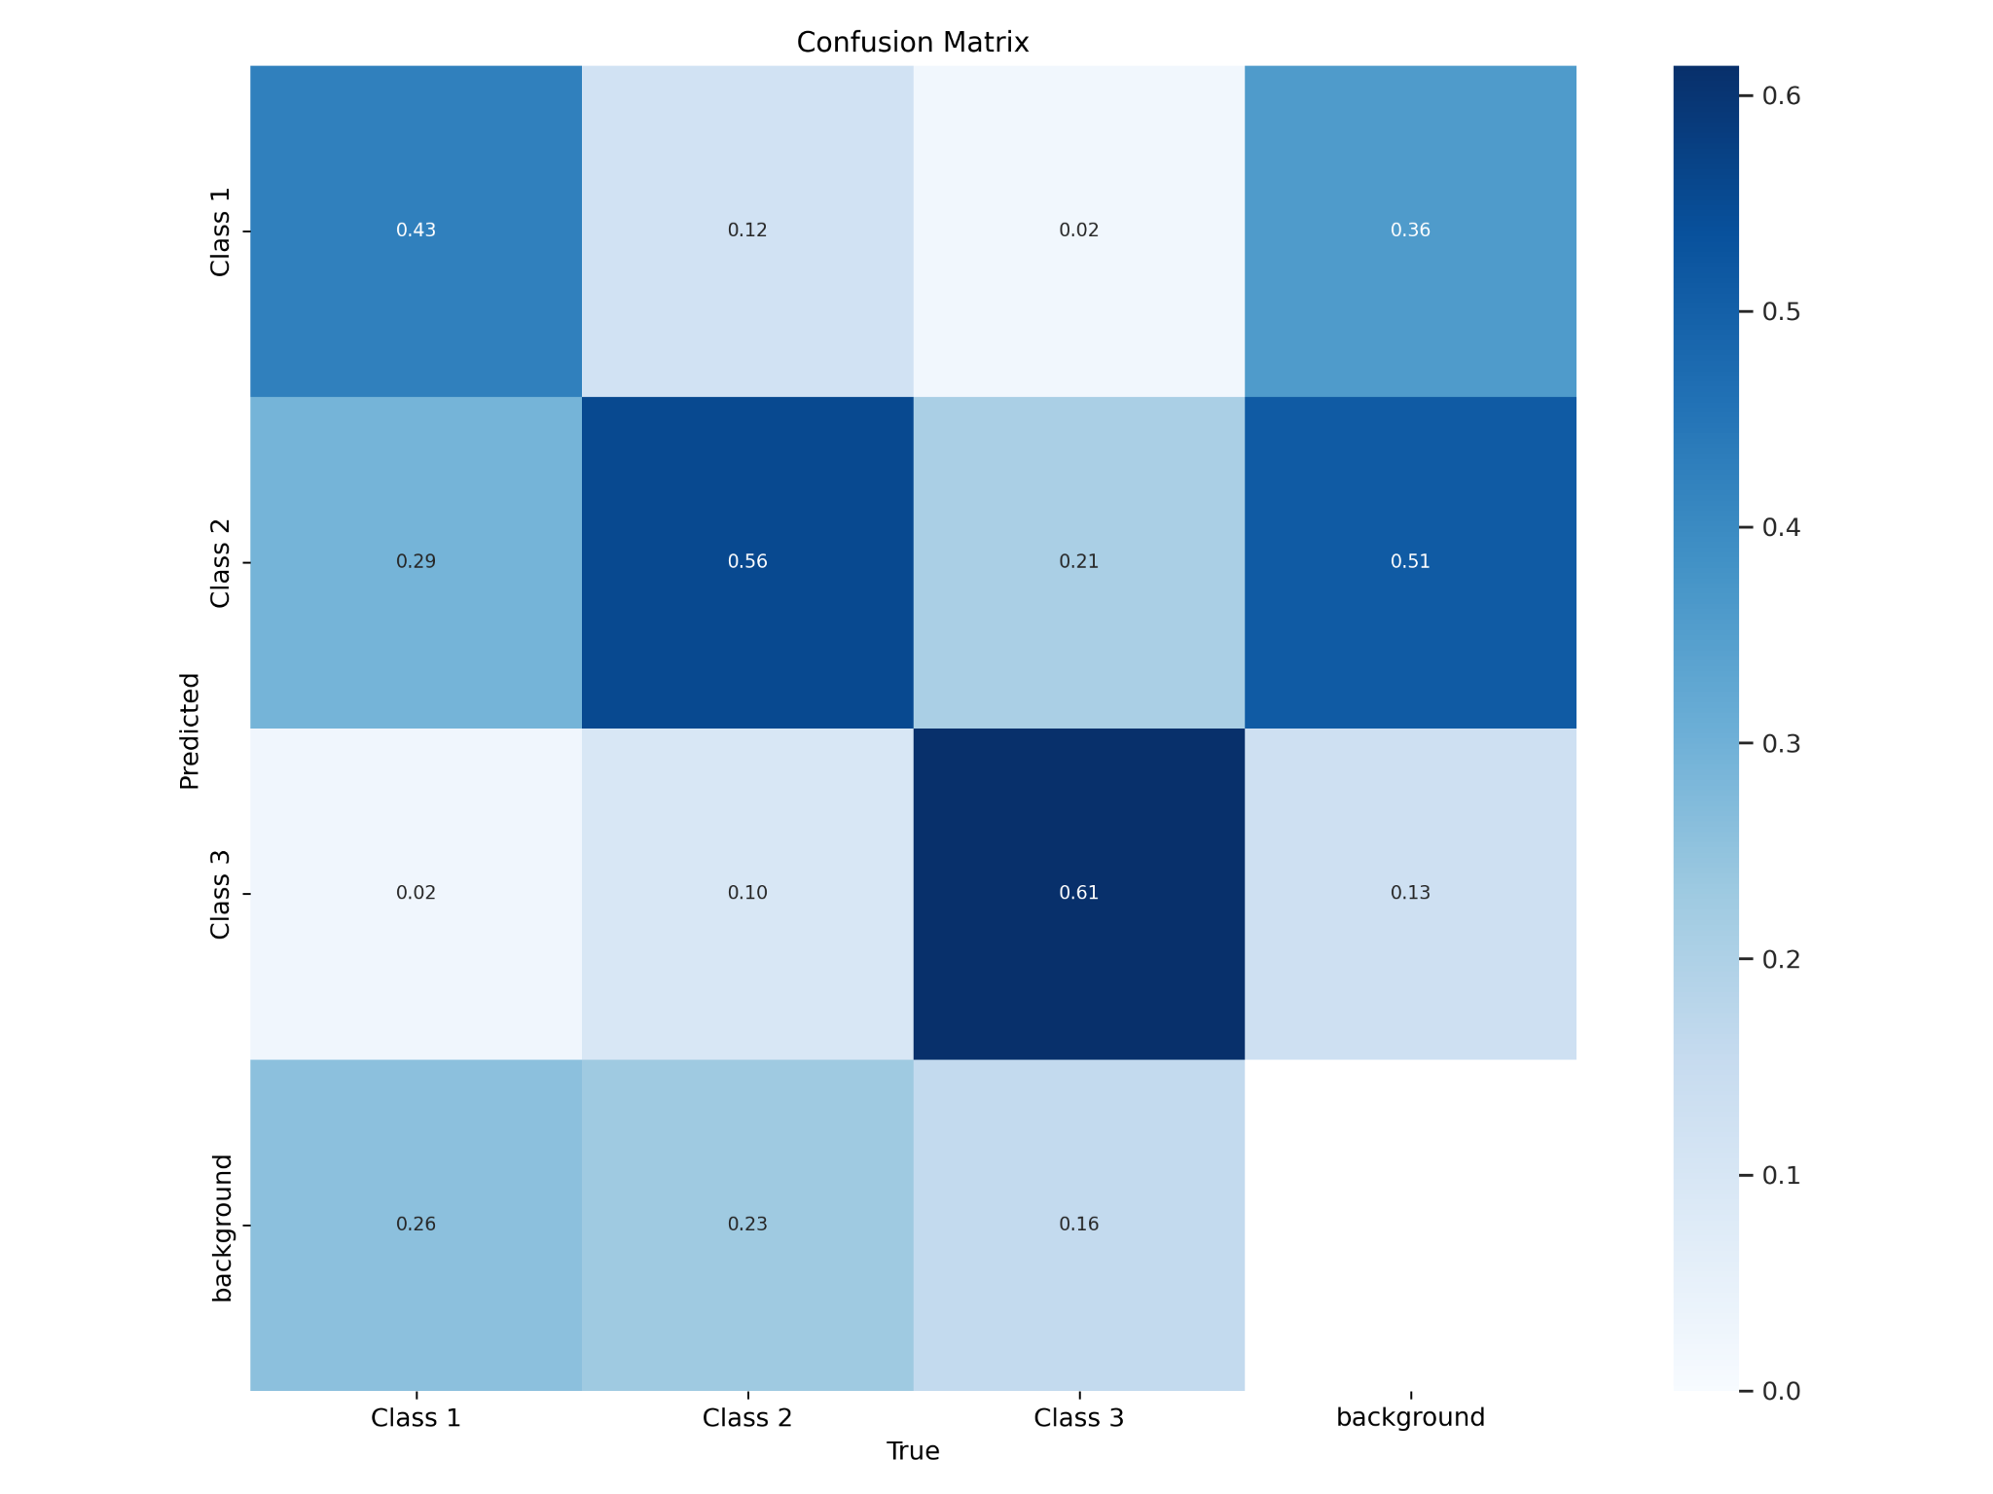
The Model performed well for classifying Class 1 amongst Class 1, Class 2, Class 3 images but since the model did not contain a lot of background data it also sometimes classified unburnt skin as Class 1 burn.

Surprisingly it classified the background as Class 2 Burn in a lot of cases. This is again attributed to the fact that background images were not provided to the model.

Other than this minor error we can conclude that the model performs sufficiently well with just 40 epochs of training.

mAP50 score, Losses, Precision, Recall

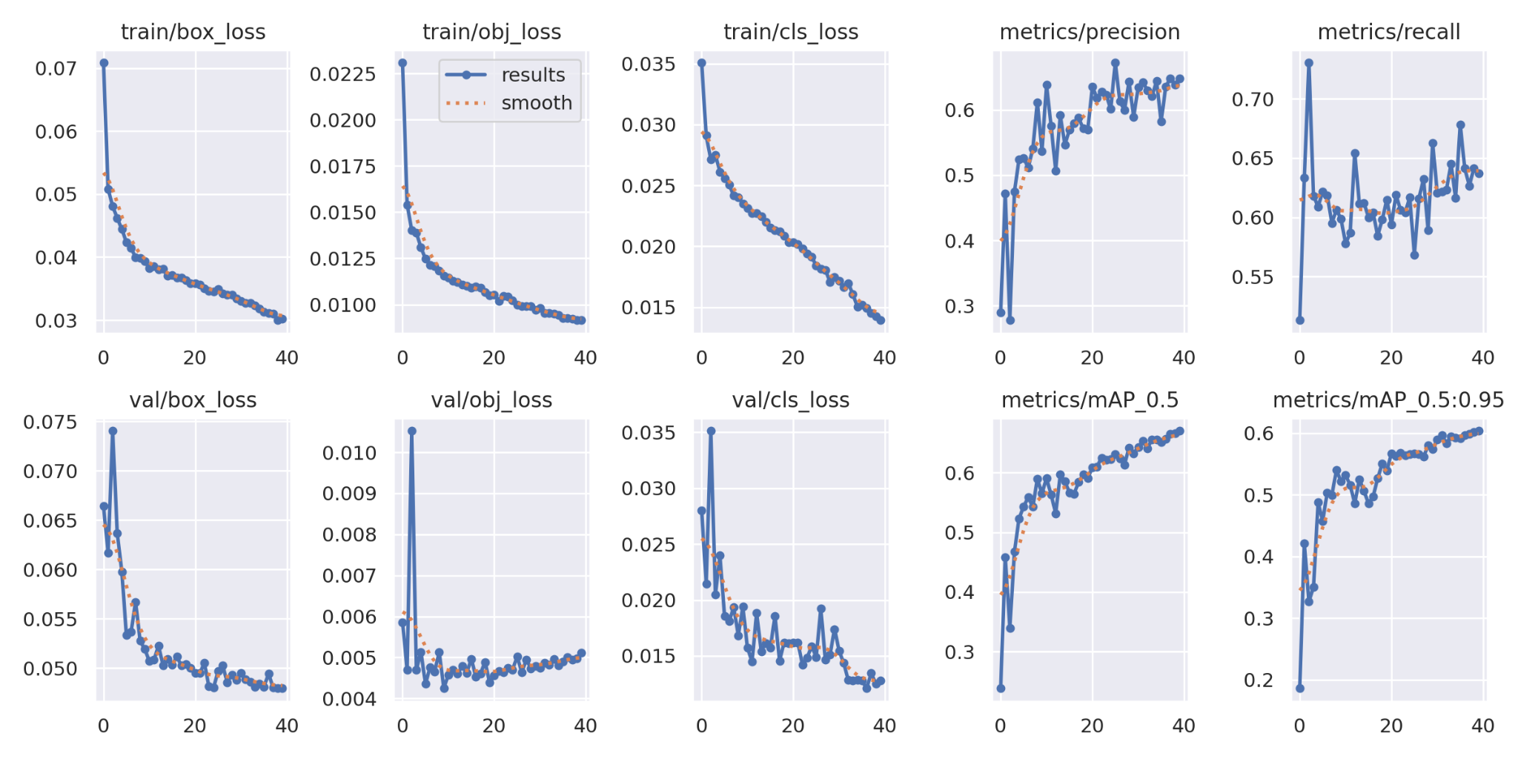

Conclusion
In this skin burn detection project, we successfully implemented a machine learning-based classifier using the YOLOv5s model. Our dataset, comprising 14,044 labeled images, provided a solid foundation for training the model. We achieved promising results, with a notable mAP score. However, minor misclassifications occurred, particularly with unburnt skin and background images.

Future work involves augmenting data, especially for Class 3 burns, to enhance model accuracy. Sourcing higher-quality data directly from hospitals and exploring advanced model architectures like YOLOvX are essential steps for improvement. Extending training epochs and incorporating background data can further refine the model's performance. Our system holds potential for broader applications in medical image analysis and patient care as we continue to refine and enhance its capabilities.

Future Work
While our skin burn detection system shows promise, there are several avenues for future work and enhancements:

- Data Augmentation: Expanding the dataset, especially for Class 3 burns, can further improve the model's ability to detect severe burns accurately. More diverse and high-quality data, possibly sourced directly from hospitals, can enhance the model's generalization.
- Improved Data Quality: Gathering data with a greater variety of body parts considered for skin burn detection can enhance the model's versatility and applicability in real-world scenarios.
- Advanced Model Architectures: Exploring advanced model architectures, such as YOLOvX or future iterations, may lead to improved performance and efficiency in skin burn detection.
- Extended Training: Extending the number of training epochs may fine-tune the model further and potentially reduce misclassifications.
- Incorporating Background Data: To mitigate the issue of background images being misclassified as Class 2 burns, incorporating background data into the training dataset should be considered.

Incorporating these future enhancements can lead to a more robust and accurate skin burn detection system, with the potential for broader applications in the field of medical image analysis and patient care.

References
- Tran, Hai & Le, Thai & Nguyen, Thuy. (2016). The Degree of Skin Burns Images Recognition using Convolutional Neural Network. Indian Journal of Science and Technology. 9. 10.17485/ijst/2016/v9i45/106772.
- Yadav DP, Sharma A, Singh M, Goyal A. Feature Extraction Based Machine Learning for Human Burn Diagnosis From Burn Images. IEEE J Transl Eng Health Med. 2019 Jul 18;7:1800507. doi: 10.1109/JTEHM.2019.2923628. PMID: 31392104; PMCID: PMC6681870.
- Chang CW, Lai F, Christian M, Chen YC, Hsu C, Chen YS, Chang DH, Roan TL, Yu YC. Deep Learning-Assisted Burn Wound Diagnosis: Diagnostic Model Development Study. JMIR Med Inform. 2021 Dec 2;9(12):e22798. doi: 10.2196/22798. PMID: 34860674; PMCID: PMC8686480.
- Sharma, Ashish. (2022). Skin Burn Detection Using Machine Learning. 10.1007/978-981-16-2597-8_36.

